Reception Class Home learning ideas and activities
Literacy
- Daily reading approximately 10 minutes per day
- Ask an adult to share a story with you/read to you.
- Phonics/reading and writing – revisit Phonic sheets already sent home each week.
- practise reading the words by sounding it out and blending together to say the whole word.
- ask an adult to say a word from the sheet – can you write it? (remember to sound it out stretching the word and writing the sounds you can hear in the order they come)
- Choose words from your sheet and put them into sentences - say your sentence several times then write it. (try to make your sentences interesting and remember to start with a capital letter and end with a full stop.
- Watch episodes of Cbeebies’ Alphablocks
- High frequency/Tricky words – (Reception list was sent home at half term) These words cannot be read using phonics and need to be learnt by sight/memory. Practice a few each day until you can read them all by sight. Then learn to write them. (tip: don’t use letter sounds/phonics, use letter names when learning to spell).
- Keep a daily diary – draw and write about what you do each day.
- Story maps and story writing – choose a story you know/ like/have enjoyed reading or hearing. Draw a map of the story – remember to think of the structure:
- beginning (setting and characters),
- middle (what is the problem/what happens
- end (how is it solved)
Can you use your map to tell the story to someone else?
Can you write the story in your own words?
Physical Development
- Handwriting - daily practice (5/10 minutes)
– CORRECT letter formation for each letter. (see the example of school handwriting style in front of homework books and attached sheet).
- Draw/ copy handwriting patterns – use different colours/pencils/pens – this will help to develop good pencil control (some examples are below and others can easily be found online)
- Go outside in the garden everyday to play and have fun and get some fresh air!
E.g. Practice throwing and catching/ kicking a ball. Ride your bike. Practise jumping, hopping, star jumps, running etc. Create your own circuit of activities/make an obstacle course.

Mathematics
- Watch episodes from CBeebies Numberblocks.
- Recite numbers daily from 0, 1, 2, 3, 4, . . . to 10/20/30 . . .? How far can you go?
Challenge: recite numbers backwards from 10/20/30
- Sort everyday objects in different sets e.g. beads, lego/building bricks, pencils toy cars etc. Challenge: Can you sort each set again e.g by colour or size (different coloured leggo/beads)
- Count different everyday objects/toys e.g. how many toy cars/ teddies/dolls/jigsaw pieces in a puzzle/building bricks do you have?
- Practice number facts for numbers from 3 to 10.
- Focus on a different number each day e.g. 4.
Make a set of 4 objects e.g. pencils/lego how many different ways can you split them into 2 parts (part, part, whole model – see example below and attached sheets if needed to support practical work for addition and subtraction)
- Draw the sets (you could draw the objects or draw a coloured circle or square to represent each one) and write the addition number sentence for each one.
3 3

2 + 1 = 3
2 1
- Can you find all possible answers? How will you know you have them all?
- Start to learn all the addition number facts by heart (especially the ones for 5 and 10)
Challenge: Can you find the subtraction/take away facts e.g. 3 – 2 = 1
- Go on a shape hunt. What 2D and 3D shapes can you find? (in the house/garden).
- Can you remember the names of the 3D shapes? (cube, cuboid, sphere, cylinder, pyramid).
- How many edges/faces/corners do they have?
- Can you make a picture using 2D shapes? e.g. a house/rocket Can you label the shapes you have used? (circle, square, triangle, rectangle).

Understanding the world (The world)
- Create a simple weather chart and record the weather each day. What symbols will you use for sun / rain /clouds etc? (tip: think about the ones we use in class to help you with ideas).
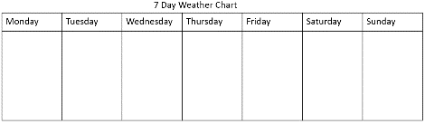

- Choose an animal to find out about and create an information fact file e.g. where it lives, what it looks like, what it can do, what it eats etc. add a picture/draw a picture of your chosen animal.
- Go outside in the garden :
- Use you senses - what can you see/hear/feel/smell?
- look for patterns in the environment e.g brick walls, paving slabs, grates fences. Can you draw them/make rubbings with a crayon and paper?
Understanding the World - People and communities (including Religious Education)
- Find out about the Christian story of Easter – The events of Holy Week from Palm Sunday to Good Friday. What happened on Easter day?

Creative (Exploring and using media and materials)
- Junk modelling using 3D shapes - make a model using recyclable materials - cardboard boxes, packaging, tubes etc. e.g. make a house, rocket, robot, /animal/dinosaur etc)
- Make musical instruments e.g. shakers using a recyclable container and beans/rice/beads.
- Listen to music/sing songs – sing favourite songs; Go to: www.musicaltod.co.uk (Mr Shepherd who teaches our music on Wednesday mornings has all the songs and more that we have been learning on his website)
- Observational drawing
- choose something from the garden/nature to draw e.g. a flower/plant/leaf – look closely at the detail. Can you put this into your drawing?
- Portraits – choose someone in your family to draw/paint
- Draw/paint a picture/ make a collage
e.g. - what you can see from a window in your house
- a character or a scene from a story you are reading/ watching on DVD/ computer

Suggested web sites:
www.phonicsplay.co.uk
choose from phase 2 and phase 3 phonics - some of the games are free and don’t need you to subscribe
www.topmarks.co.uk
Go to the Learning Resources tab for Maths and English online activities and games for different ages e.g. 3-5/5-7/7-11 years
- English activities: – e.g. letters & sounds; punctuation; words and spelling; learning to read; stories
- Maths activities: - e.g. counting, ordering, sequencing numbers; place value; addition & subtraction shapes, measures
There is also a useful Parent’s Resources tab, with useful information and ideas to help your child with their learning.

www.oxfordowl.co.uk
Oxford Owl for Home – Free resources to support learning at home – also check the new parent website link
- advice & support for parents
- Educational activities and games
- Free eBook library for 3- 11 Year olds

Handwriting – Letter formation and style
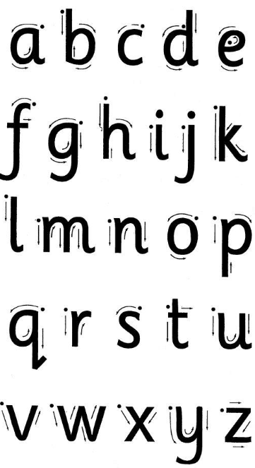

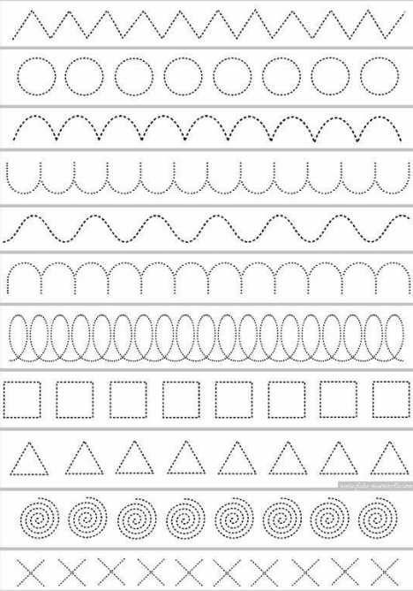
Examples of Handwriting patterns

Addition work mat

Whole

Part Part

+ =

Subtraction work mat

Whole

Part Part

- =

